

Product Specifications
Customer
Model Name | S035Q01
Description | Stand LCD Module  320x3RGBx240 Dots  3.5" TFT LCD
Date | 2011/12/07
Revision | 1.2

Customer Approval
Date
The above signature represents that the product specifications, testing regulation, and warranty in the specifications are accepted

Elpa Displays, Inc. - 2300 N. Barrington Road #400 - Hoffman Estates, Il 60169 - Ph: 847-519-7205 - Email: info@elpadisplays.com

Engineering
Check | Date | Prepared | Date

Table of Contents
Coversheet................................................................................................................................1

Record of Revision....................................................................................................................3

1. General Specifications ...................................................................................................4

2. Input/Output Terminals ...................................................................................................5

3 Absolute Maximum Ratings ............................................................................................6

4 Electrical Characteristics................................................................................................. 6

5 Timing Chart....................................................................................................................8

6 Optical Characteristics ..................................................................................................14

7 Environmental / Reliability Tests....................................................................................16

8 Mechanical Drawing......................................................................................................18

9 Packing Drawing ...........................................................................................................19

10 Precautions For Use of LCD modules..........................................................................20

Record of Revision
Rev | Issued Date | Description | Editor
V1.1 | 2011/04/16 | First Release. | Richard Liang
V1.2 | 2011/12/07 | Add SPI Command | Tiger
1 General Specifications
Feature |  | Spec
Characteristics | Size | 3.5inch
Characteristics | Resolution | 320(RGB) X 240
Characteristics | Interface | RGB
Characteristics | Color Depth | 24bit
Characteristics | Technology type | a-Si
Characteristics | Display Spec. Pixel pitch (mm) | 0.219 x 0.219
Characteristics | Display colors | 16.7M Dithering
Characteristics | Pixel Configuration | R.G.B. Vertical Stripe
Characteristics | Display Mode | Normally White
Characteristics | Surface Treatment | HC
Characteristics | Gray Scale Inversion Direction | 12 CLOCK
Mechanical | LCM (W x H x D) (mm) | 76.9*64.0*3.05
Mechanical | Active Area(mm) | 70.08 x 52.56
Mechanical | With /Without TSP | Without TSP
Mechanical | Weight (g) | TBD
Mechanical | LED Numbers | 6 LEDs

Note 1: Viewing direction for best image quality is different from TFT definition, there is a 180 degree shift.
Note 2: Requirements on Environmental Protection: RoHS
Note 3: LCM weight tolerance: +/- 5%

2 Input/Output Terminals
Pin assignment
Pin No. | Symbol | Description
1,2 | VBL- | Backlight LED Cathode
3,4 | VBL+ | Backlight LED Anode.
5~7 | NC | NC
8 | RESET | Reset Signal pin (“Low” is enable)
9 | CS | Chip select
10 | SCL | Serial Clock.
11 | SDI | Serial Data
12-19 | B0~B7 | Data bus
20-27 | G0~G7 | Data bus
28-35 | R0~R7 | Data bus
36 | HSYNC | Line Synchronous Signal
37 | VSYNC | Frame Synchronous Signal
38 | DOTCLK | Dot-clock signal and oscillator source
39-40 | NC | NC
41-42 | VCC | Power supply for logic operation
43-47 | NC | NC
48 | NC | NC
49 | NC | NC
50 | NC | NC
51 | NC | NC
52 | DEN | Display enable signal
53-54 | GND | System Ground

- Absolute Maximum Ratings
Driving TFT LCD Panel
Item | Symbol | MIN | MAX | Unit | Remark
Supply Voltage | VDD | -0.3 | 5.0 | V
Operating Temperature | TOPR | -20 | 70 | ℃
Storage Temperature | TSTG | -30 | 80 | ℃

- Electrical Characteristics
  - Driving TFT LCD Panel
Item |  | Symbol | MIN | TYP | MAX | Unit | Remark
Supply Voltage |  | VDD | 3.0 | 3.3 | 3.6 | V
Input Signal Voltage | Low Level | VIL | GND | - | 0.1x VDD | V
Input Signal Voltage | High Level | VIH | 0.8x VDD | - | VDD | V
TFT Common Electrode |  | VcomH | 2.5 | - | 4.5 | V
Voltage |  | VcomL | -3 | - | 0 | V
TFT Gata ON Voltage |  | VcomH |  |  | 15 | V
TFT Gata OFF Voltage |  | VcomL | -10 |  |  | V

4.2 Driving Backlight
Parameter | Symbol | Conditions | Min. | Typ. | Max. | Unit
Supply voltage of white LED backlight | VLED  =V(BL+)-  V(BL-) | Forward current  =20mA  Number of LED dies = 6 |  | 19.8V |  | V

Note : The figure below shows the connection of backlight LED.

4.3 Block Diagram
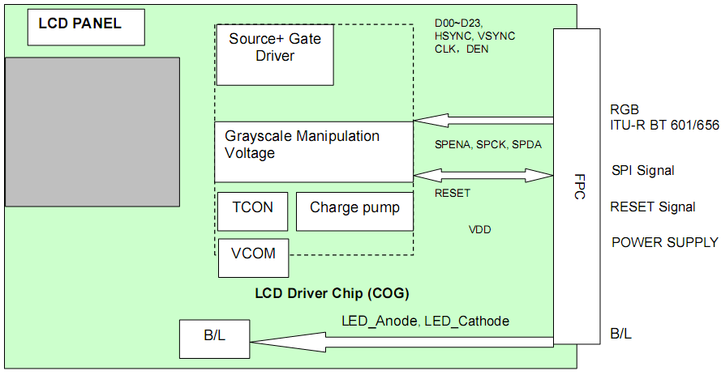

5 Timing Chart

5.1 AC Electrical Characteristics
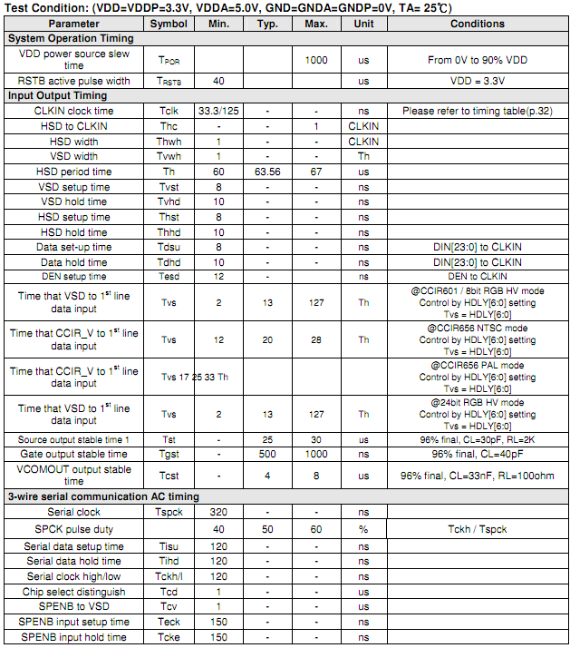

5.2 24 Bit RGB Mode (@ SEL\[3:0] = 1100 or 1101)
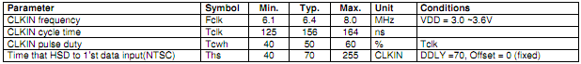

5.3 Timing Diagram
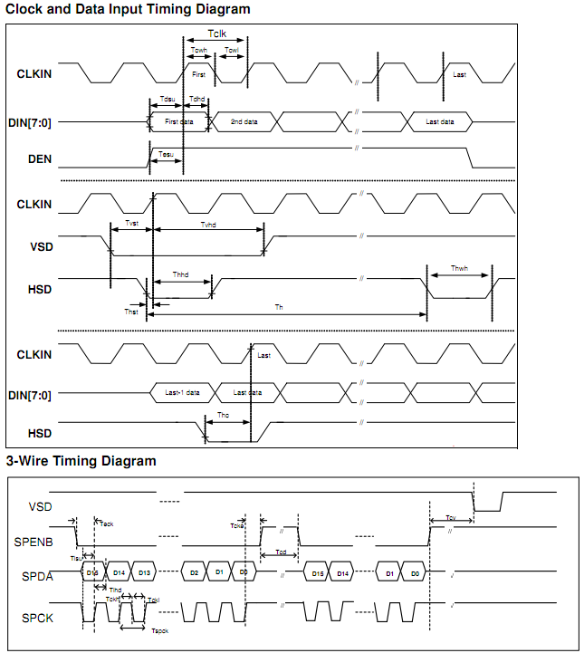

5.4 Vertical Timing Diagram (HV Mode)
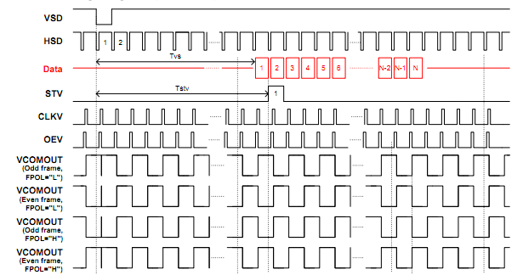

5.5 Vertical Timing Diagram (DE Mode)
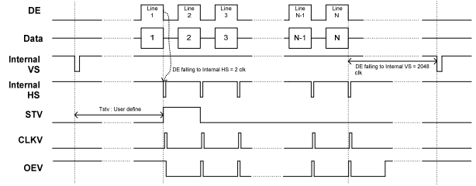

5.6 Input Data Timing (24 bit RGB mode for 960 x 240 @ SEL\[3:0] = 1100b)
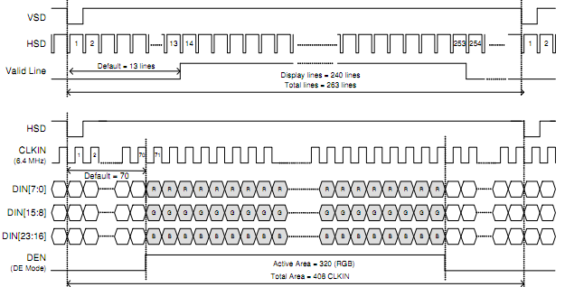

5.7 3-Wire Serial Port Interface (Default Register Map)
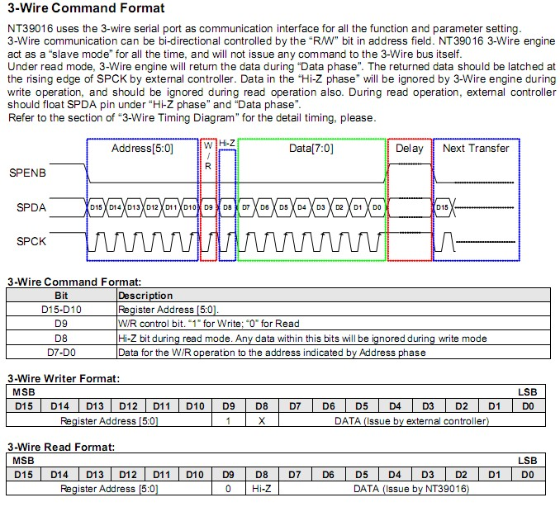

void SPIByteWrite(unsigned char reg, unsigned char data)
{
int i;
int j;
unsigned short value=0;
value= (reg & 0x3f) << 10;
value |= (0x0200 | data);
for(i=0;i<16;i++)
{
LCDCSLow();
LCDClockLow();
msWait(25);
j=value& 0x8000;
if(j==0x8000)
{
LCDDataHigh();
}
else
{
LCDDataLow();
}

msWait(25);
LCDClockHigh();
msWait(25);
value<<=1;
}
LCDCSHigh();
msWait(200);
}
//*******************Send SPI Command*************************//
SPIByteWrite(0x01,0x00);
SPIByteWrite(0x02,0x03);//HDNC[1:0] //0x03
SPIByteWrite(0x03,0xcc);//c4 or c5
SPIByteWrite(0x04,0x46);
SPIByteWrite(0x05,0x0d);
SPIByteWrite(0x06,0x00);
SPIByteWrite(0x07,0x00);
SPIByteWrite(0x08,0x08);
SPIByteWrite(0x09,0x40);
SPIByteWrite(0x0a,0x88);
SPIByteWrite(0x0b,0x88);
SPIByteWrite(0x0c,0x20);
SPIByteWrite(0x0d,0x20);
SPIByteWrite(0x0e,0x67); //0x62
SPIByteWrite(0x0f,0xA4);
SPIByteWrite(0x10,0x04);
SPIByteWrite(0x11,0x24);
SPIByteWrite(0x12,0x24);
SPIByteWrite(0x1E,0x00);
SPIByteWrite(0x20,0x00); // WNSEL1[1:0]
6 Optical Characteristics

Optical specifications
Items |  | Symbol | Condition | Specifications |  |  | Unit | Note
 |  | Symbol | Condition | Min. | Typ. | Max. | Unit | Note
Contrast Ratio |  | CR |  | - | 350 | - | - | Note
Response Time |  | T_{R} |  | - | 25 | 40 | ms | Note
 |  | T_{F} |  | - | 25 | 40 | ms | Note
Chromaticity | Red | X_{R} |  | 0.586 | 0.636 | 0.686 | - | Note
Chromaticity | Red | Y_{R} |  | 0.300 | 0.350 | 0.400 | - | Note
Chromaticity | Green | X_{G} |  | 0.261 | 0.311 | 0.361 | - | Note
Chromaticity | Green | Y_{G} |  | 0.501 | 0.551 | 0.601 | - | Note
Chromaticity | Blue | X_{B} |  | 0.084 | 0.134 | 0.184 | - | Note
Chromaticity | Blue | Y_{B} |  | 0.101 | 0.151 | 0.201 | - | Note
Chromaticity | White | X_{W} |  | 0.261 | 0.311 | 0.361 | - | Note
Chromaticity | White | Y_{W} |  | 0.300 | 0.353 | 0.400 | - | Note
Viewing angle | Hor. | 1(3 o’clock) | Center  CR≥10 | 50 | 60 | - | deg. | Note
Viewing angle | Hor. | 2(9 o’clock) | Center  CR≥10 | 50 | 60 | - | deg. | Note
Viewing angle | Ver. | 2(12 o’clock) | Center  CR≥10 | 30 | 40 | - | deg. | Note
Viewing angle | Ver. | 1(6 o’clock) | Center  CR≥10 | 50 | 60 | - | deg. | Note
NTSC ratio |  |  |  |  | 50 |  | % | Note
Luminance |  |            L |  | 250 | 300 |  |  | Note
Note 1: Definition of Contrast Ratio (CR):
The contrast ratio can be calculated by the following expression.
Contrast Ratio (CR) = L63 / L0
L63: Luminance of gray level 63
L0: Luminance of gray level 0
CR = CR (10)
CR (X) is corresponding to the Contrast Ratio of the point X at Figure in Note 5.

Note 2: Definition of Response Time (TR, TF):
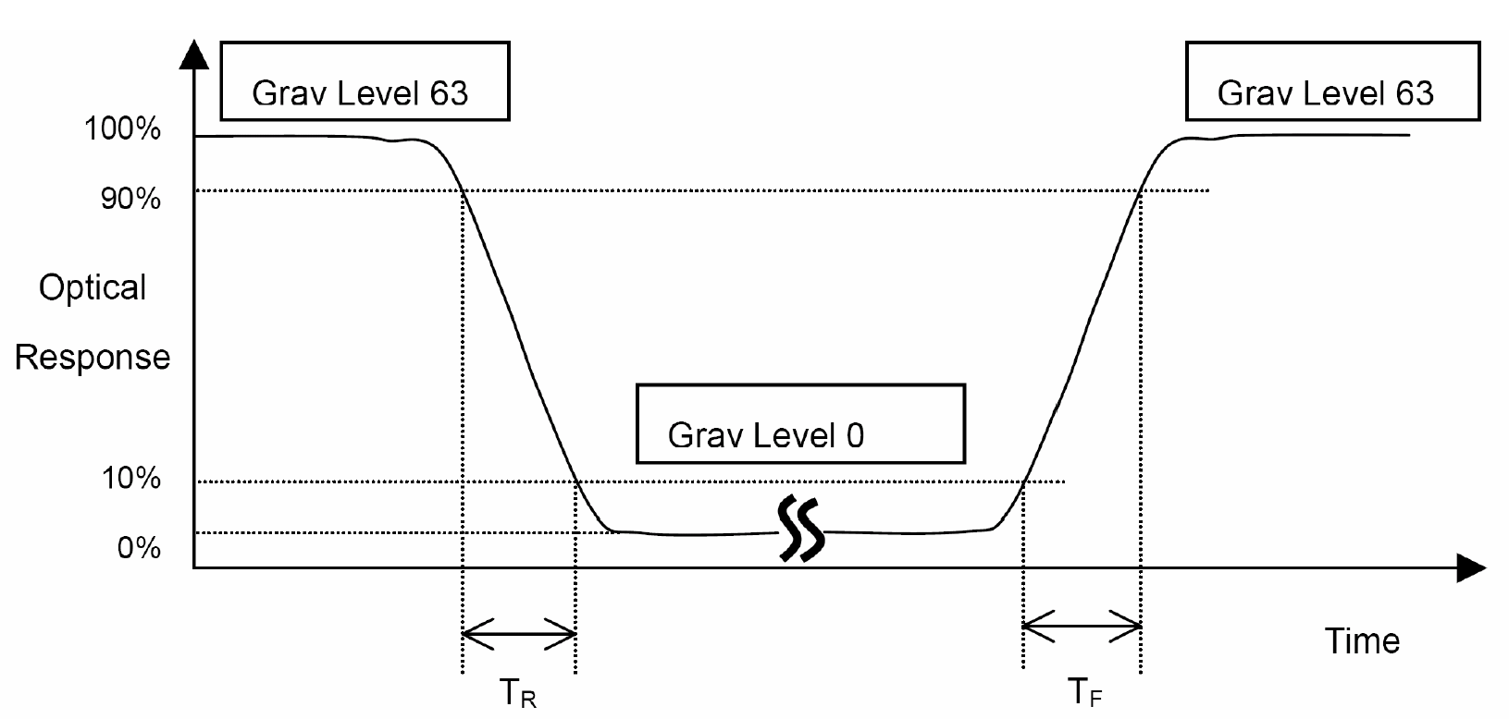

Note 3: Viewing Angle
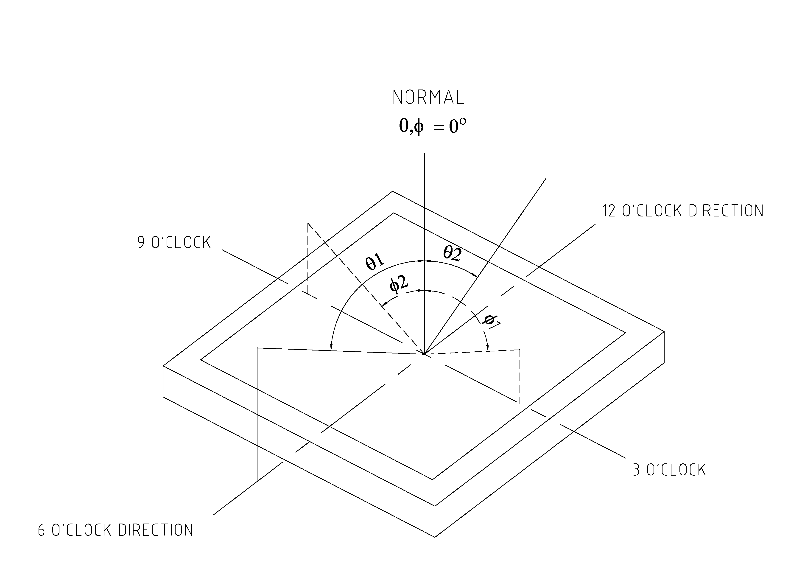
The above “Viewing Angle” is the measuring position with Largest Contrast Ratio; not for good image quality. View Direction for good image quality is 6 O’clock. Module maker can increase the “Viewing Angle” by applying Wide View Film.

Note 4: Measurement Set-Up:
The LCD module should be stabilized at a given temperature for 20 minutes to avoid abrupttem perature change during measuring. In order to stabilize the luminance, the measurement
should be executed after lighting Backlight for 20 minutes in a windless room.
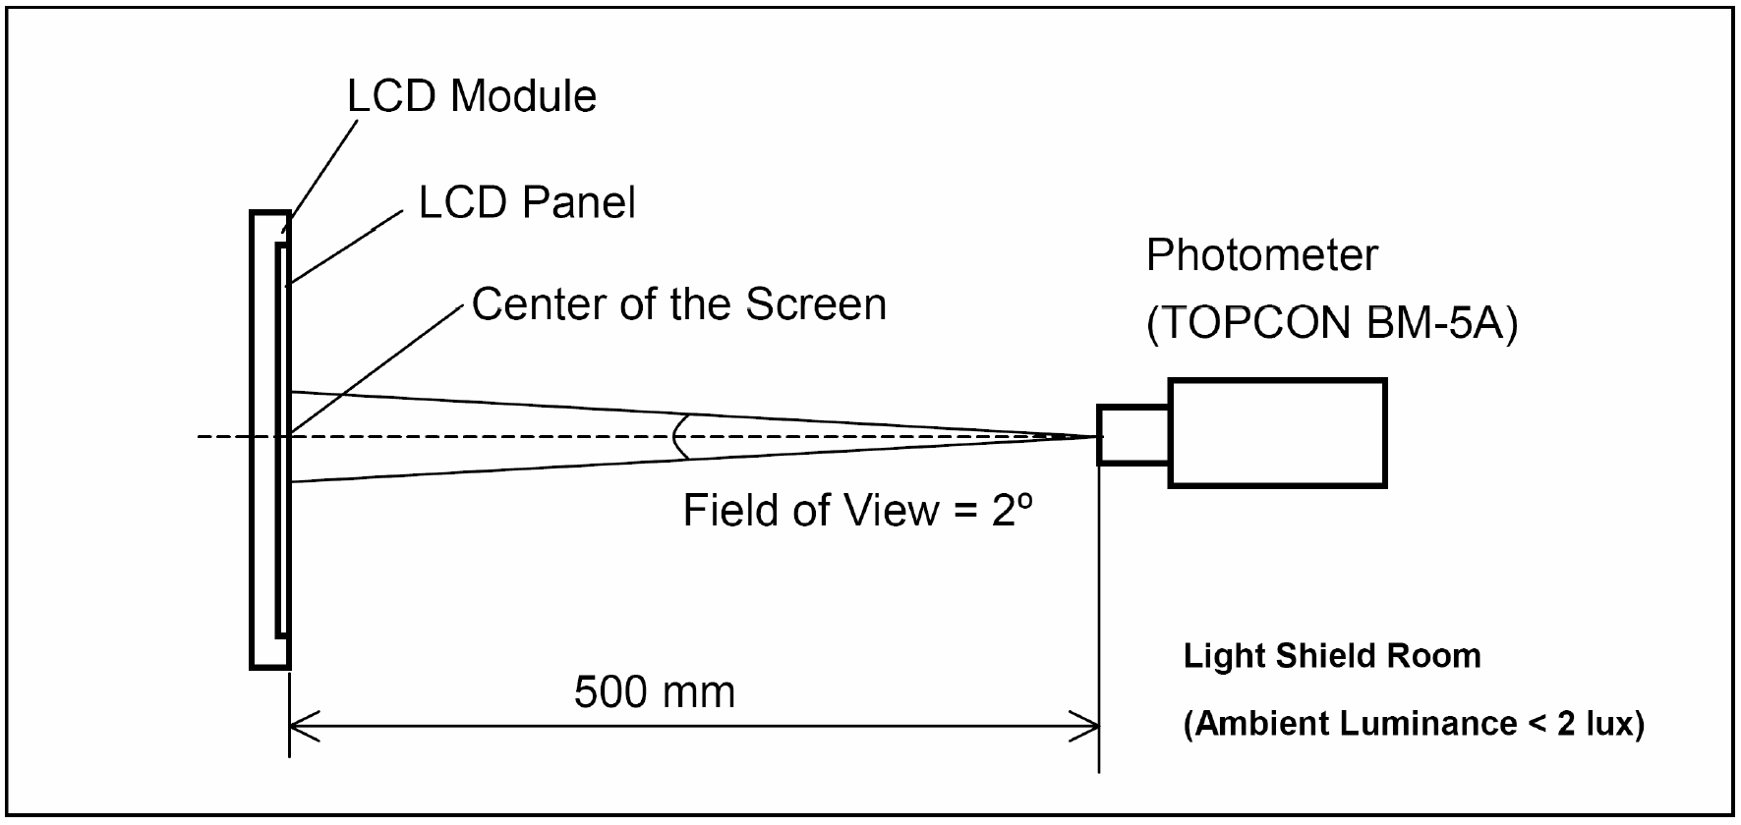

7 Environmental / Reliability Tests
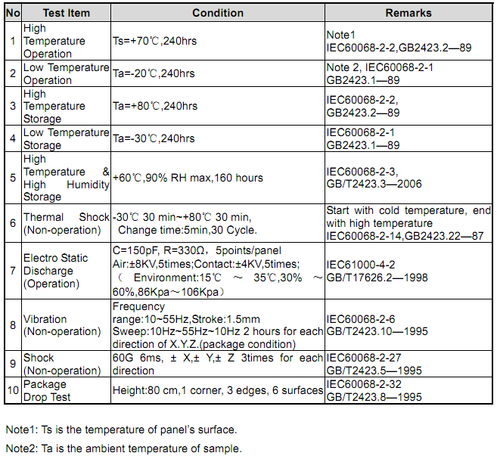

8 Mechanical Drawing

9 Packing
Packing Method
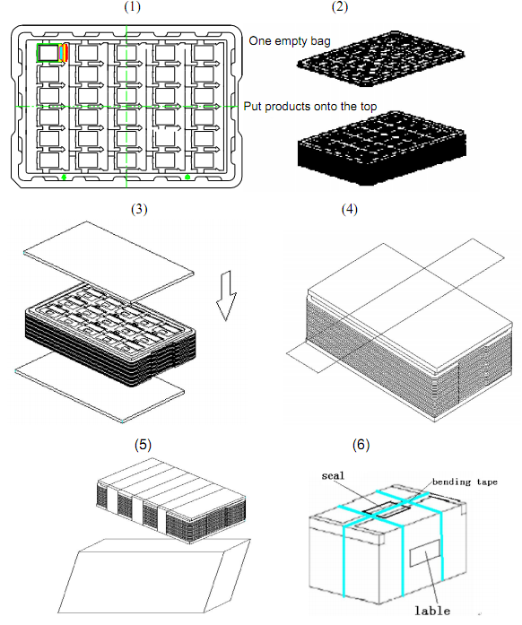
1. Put module into tray cavity:
2. Tray stacking
3. Put 1 cardboard under the tray stack and 1 cardboard above:
4. Fix the cardboard to the tray stack with adhesive tape:
5. Put the tray stack into carton.
6. Carton sealing with adhesive tape.
10 Precautions For Use of LCD modules

10.1 Handling Precautions
10.1.1. The display panel is made of glass. Do not subject it to a mechanical shock by dropping it from a high place, etc.
10.1.2. If the display panel is damaged and the liquid crystal substance inside it leaks out, be sure not to get any in your mouth, if the substance comes into contact with your skin or clothes, promptly wash it off using soap and water.
10.1.3. Do not apply excessive force to the display surface or the adjoining areas since this may cause the color tone to vary.
10.1.4. The polarizer covering the display surface of the LCD module is soft and easily scratched. Handle this polarizer carefully.
10.1.5. If the display surface is contaminated, breathe on the surface and gently wipe it with a soft dry cloth. If still not completely clear, moisten cloth with one of the following solvents:
－ Isopropyl alcohol
－ Ethyl alcohol
Solvents other than those mentioned above may damage the polarizer. Especially, do not use the following:
－ Water
－ Ketone
－ Aromatic solvents
10.1.6. Do not attempt to disassemble the LCD Module.
10.1.7. If the logic circuit power is off, do not apply the input signals.
10.1.8. To prevent destruction of the elements by static electricity, be careful to maintain an optimum work environment.

10.1.8.1. Be sure to ground the body when handling the LCD Modules.
10.1.8.2. Tools required for assembly, such as soldering irons, must be properly ground.

10.1.8.3. To reduce the amount of static electricity generated, do not conduct assembly and other work under dry conditions.
10.1.8.4. The LCD Module is coated with a film to protect the display surface. Be care when peeling off this protective film since static electricity may be generated.
10.2 Storage Precautions
10.2.1. When storing the LCD modules, avoid exposure to direct sunlight or to the light of fluorescent lamps.
10.2.2. The LCD modules should be stored under the storage temperature range If the LCD modules will be stored for a long time, the recommend condition is:
Temperature : 0℃ ～ 40℃ Relatively humidity: ≤80%
10.2.3. The LCD modules should be stored in the room without acid, alkali and harmful gas.

10.3 Transportation Precautions
The LCD modules should be no falling and violent shocking during transportation, and also should avoid excessive press, water, damp and sunshine.

